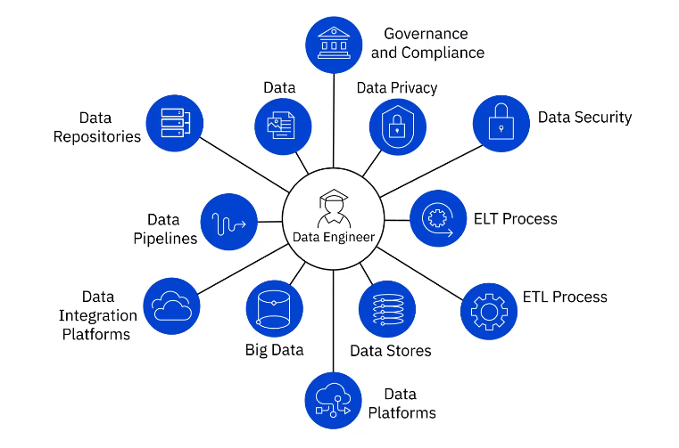

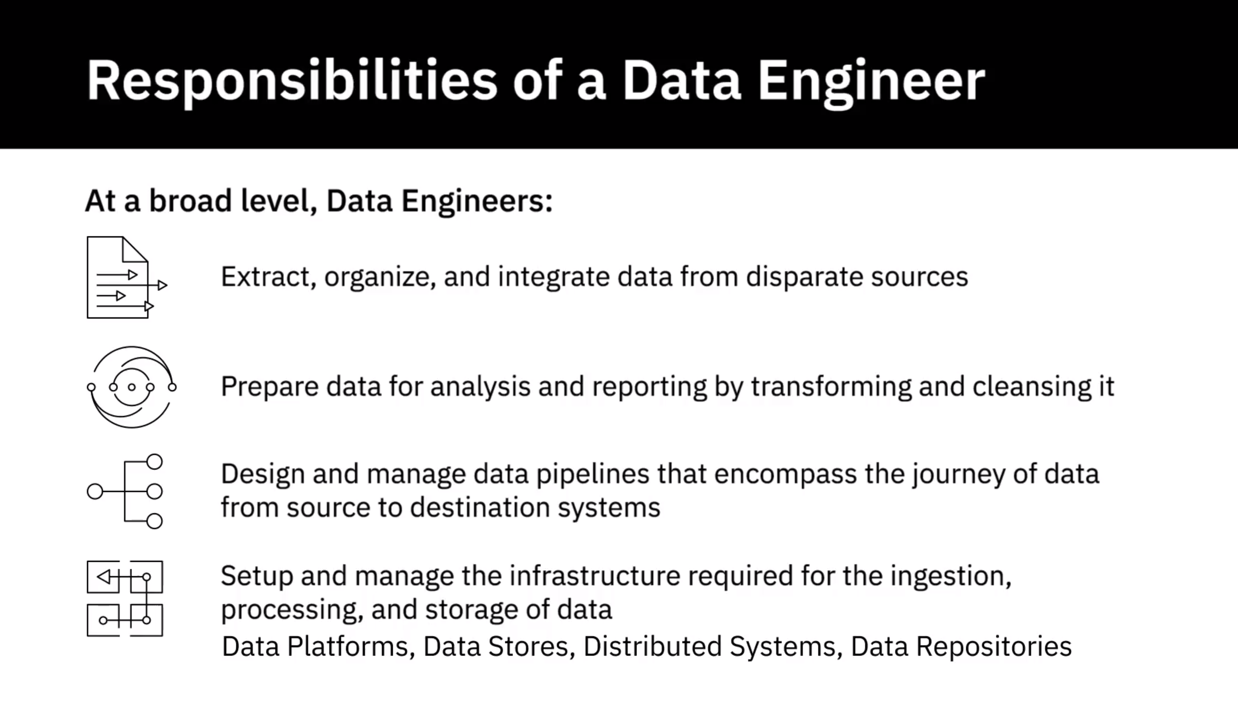

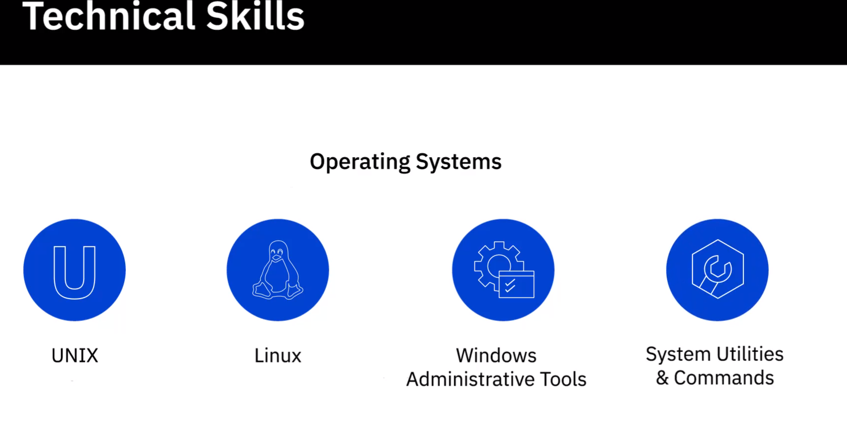

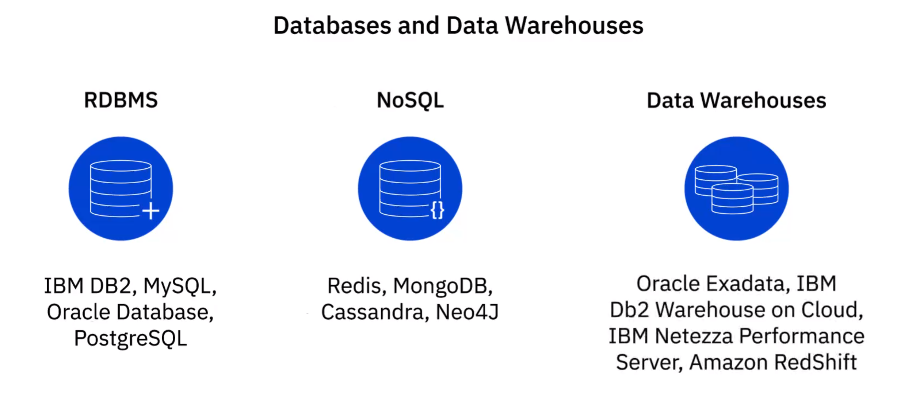

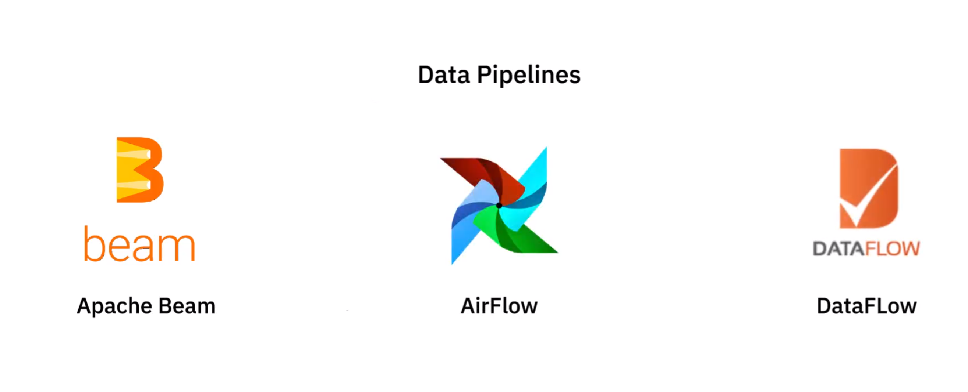



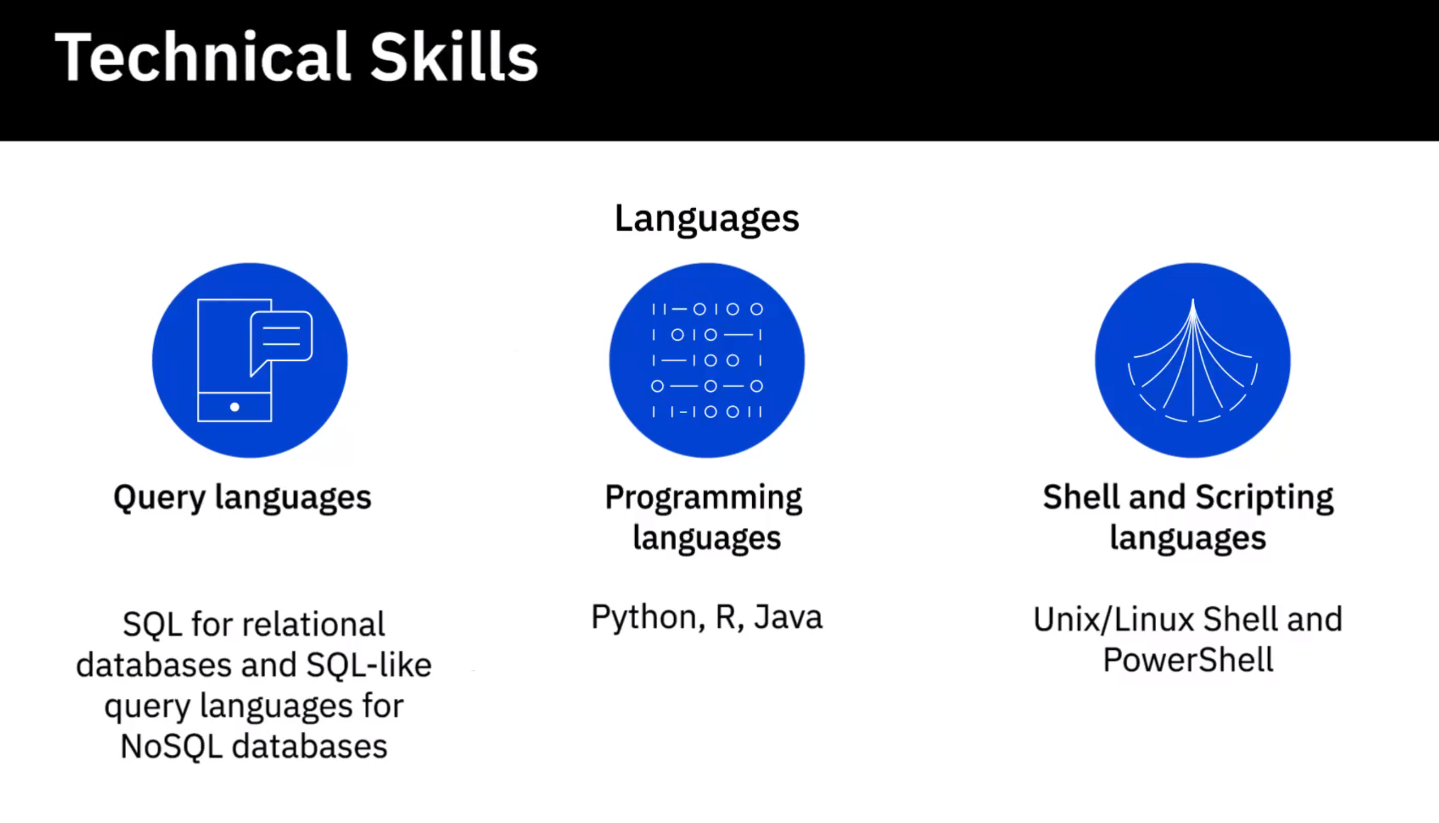

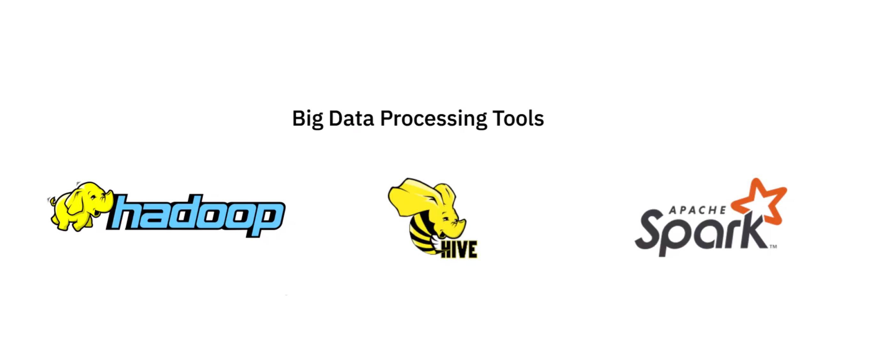

Functional Skills:

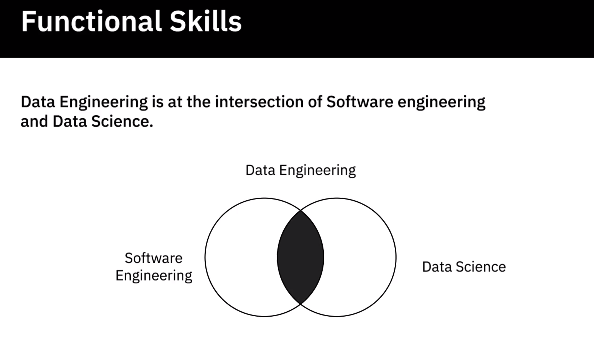

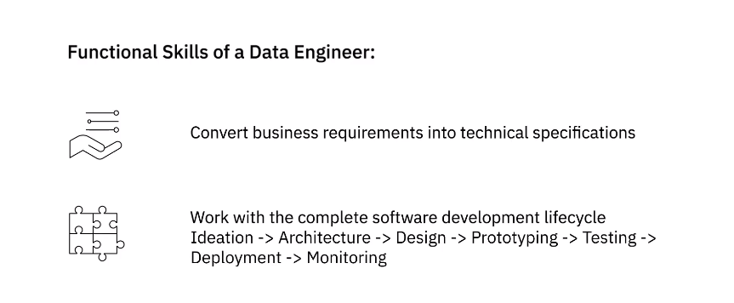

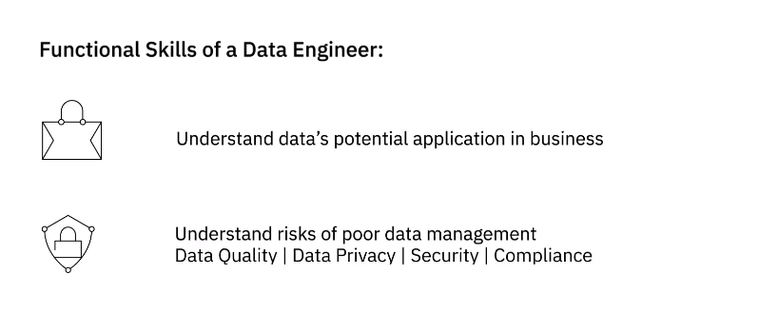

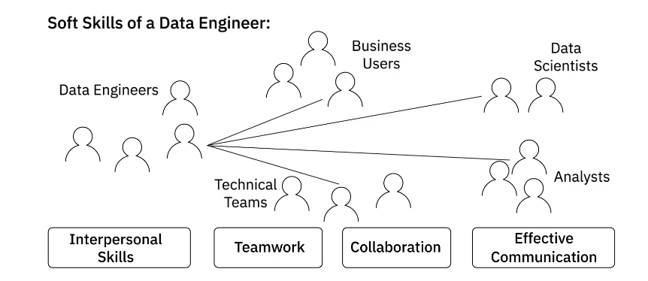

**Video: Viewpoints: Skills and Qualities to be a Data Engineer (6:58)**

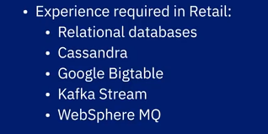

**Video: A Day in the Life of a Data Engineer (3:37)**

**Video: Overview of the Data Engineering Ecosystem (4:53)**

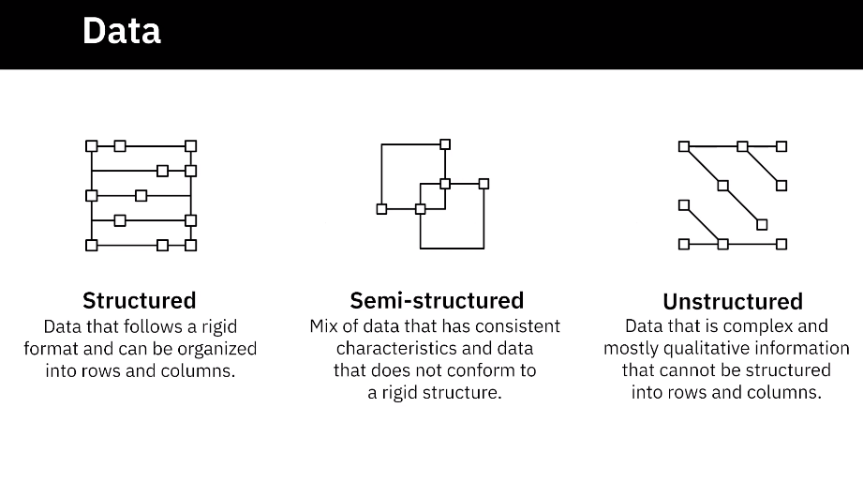

Data Sources

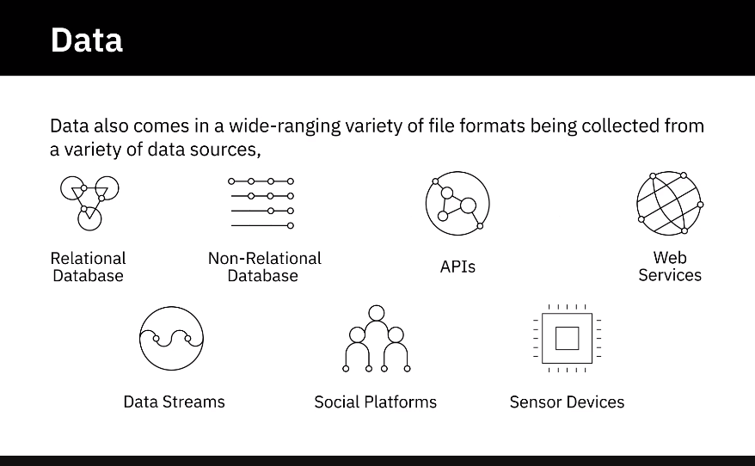

Data Repositories

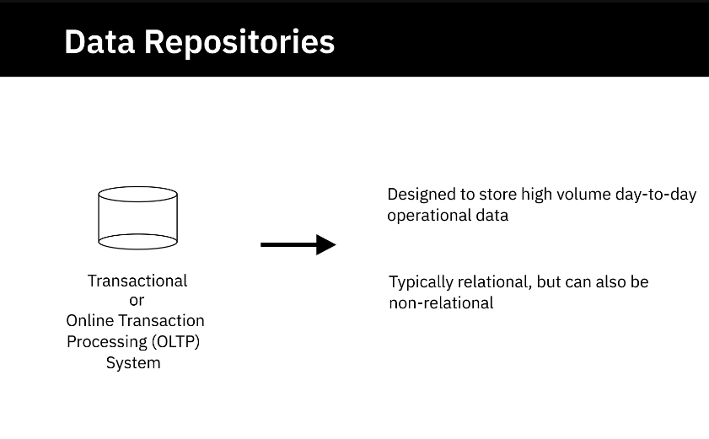

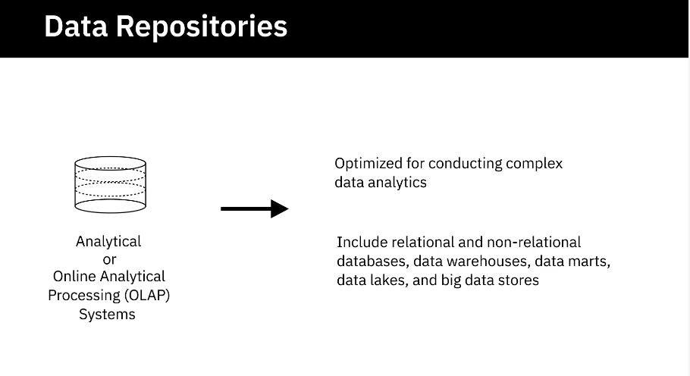

Data Integartion

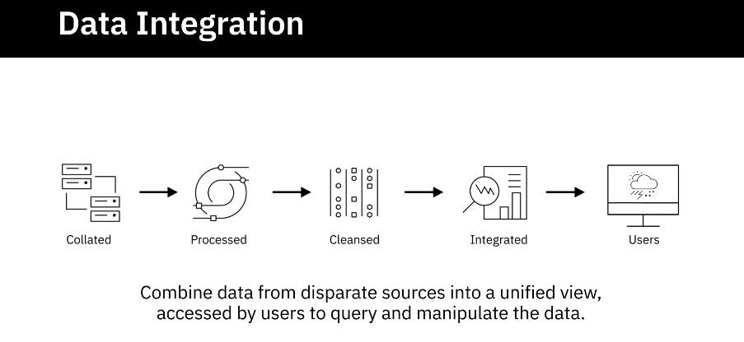

Data Pipeline

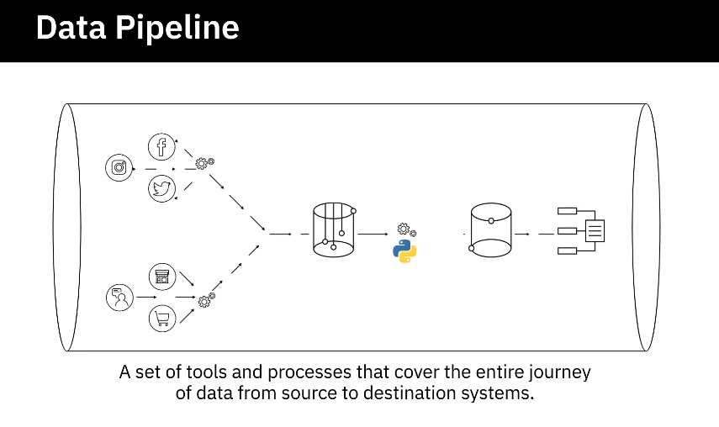

Languages

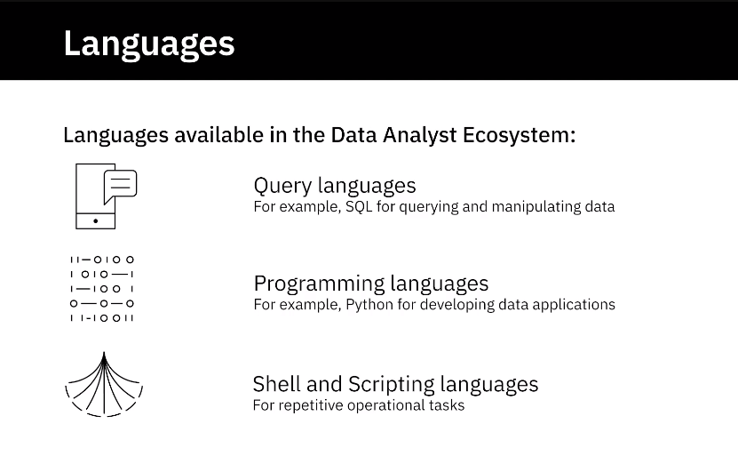

BI and Reporting Tools

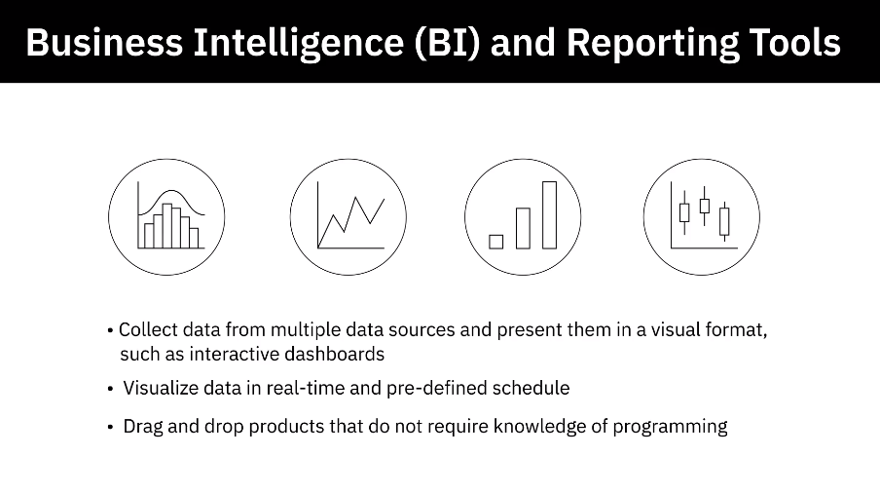

**Video: Types of Data (4:02)**

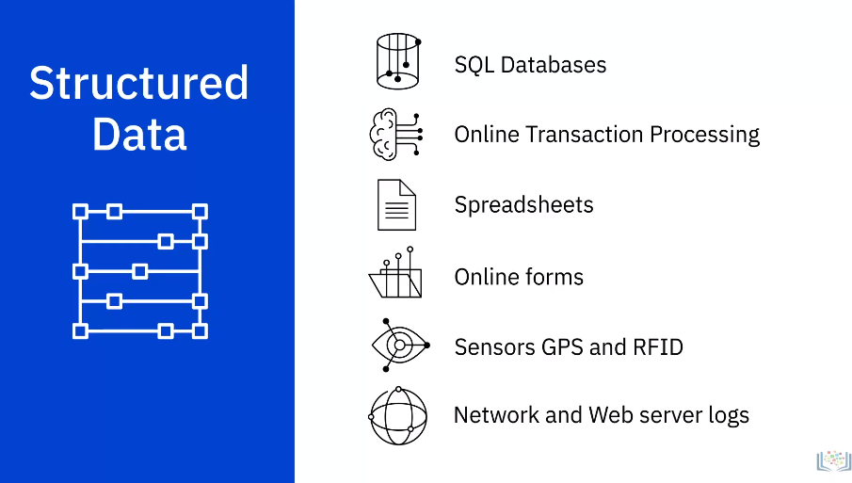

1. Structured data has a well-defined structure or adheres to a specified data model
2. can be stored in well-defined schemas such as databases
3. and in many cases can be represented in a tabular manner with rows and columns.
4. **Structured data is objective facts and numbers that can be collected, exported, stored, and**
5. organized in typical databases.
6. Some of the sources of structured data could include:
7. SQL Databases and Online Transaction Processing (or OLTP) Systems that focus on business transactions
8. Spreadsheets such as Excel and Google Spreadsheets
9. Online forms
10. Sensors such as Global Positioning Systems (or GPS) and Radio Frequency Identification
11. (or RFID) tags; and Network and Web server logs.
12. You can typically store structured data in relational or SQL databases.
13. You can also easily examine structured data with standard data analysis methods and tools.

**Video: Understanding Different Types of File Formats (5:00)**

CSV

XLSX

XML

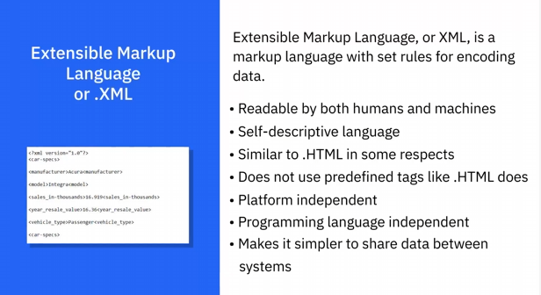

PDF

JSON

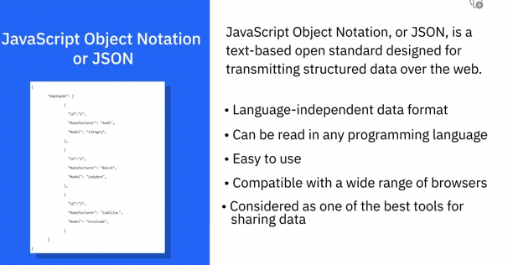

**Video: Sources of Data (7:57)**

**Common Sources of data**

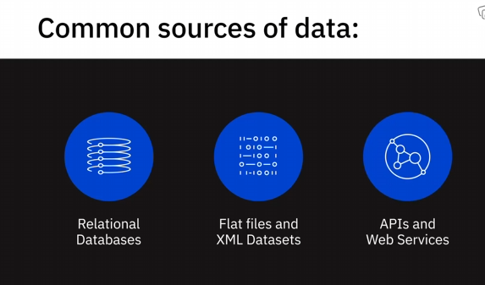

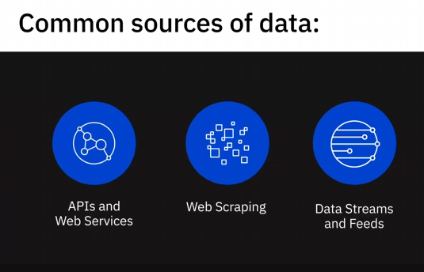

Relational Databases

Flat Files

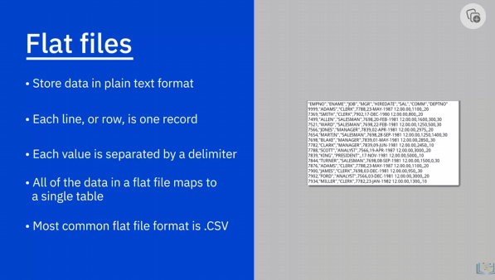

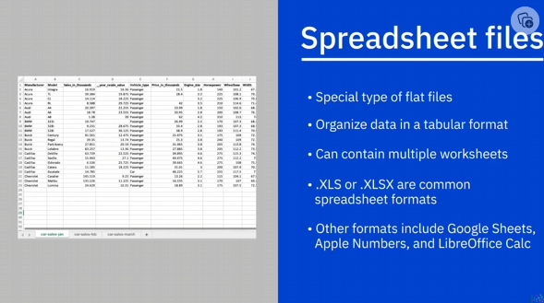

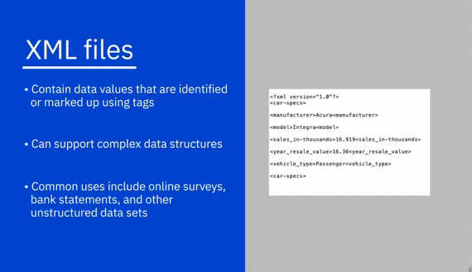

1. XML files, contain data values that are identified or marked up using tags.
2. While data in flat files is “flat” or maps to a single table, XML files can support
3. more complex data structures, such as hierarchical.
4. Some common uses of XML include data from online surveys, bank statements, and other
5. unstructured data sets.

APIs

1. Many data providers and websites provide APIs, or Application Program Interfaces, and Web
2. Services, which multiple users or applications can interact with and obtain data for processing
3. or analysis.
4. APIs and Web Services typically listen for incoming requests, which can be in the form
5. **of web requests from users or network requests from applications, and return data in plain**
6. text, XML, HTML, JSON, or media files.
7. Let’s look at some popular examples of APIs being used as a data source for data analytics:
8. The use of Twitter and Facebook APIs to source data from tweets and posts for performing
9. tasks such as opinion mining or sentiment analysis—which is to summarize the amount
10. of appreciation and criticism on a given subject, such as policies of a government, a product,
11. a service, or customer satisfaction in general.
12. Stock Market APIs used for pulling data such as share and commodity prices, earnings per
13. share, and historical prices, for trading and analysis.
14. Data Lookup and Validation APIs, which can be very useful for Data Analysts for cleaning
15. and preparing data, as well as for co-relating data—for example, to check which city or
16. state a postal or zip code belongs to.
17. APIs are also used for pulling data from database sources, within and external to the organization.

Web Scraping

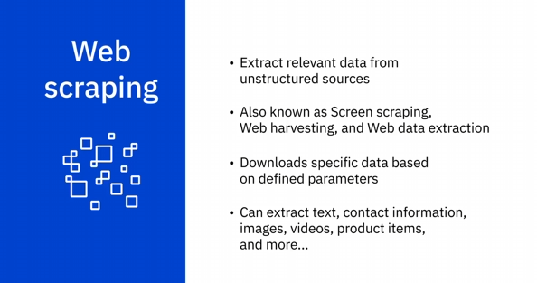

1. Web ScrapingWeb scraping is used to extract relevant data from unstructured sources.
2. Also known as screen scraping, web harvesting, and web data extraction, web scraping makes
3. it possible to download specific data from web pages based on defined parameters.
4. **Web scrapers can, among other things, extract text, contact information, images, videos,**
5. product items, and much more from a website.
6. Some popular uses of web scraping include
7. collecting product details from retailers, manufacturers, and eCommerce websites to provide
8. price comparisons;
9. generating sales leads through public data sources;
10. extracting data from posts and authors on various forums and communities;
11. and collecting training and testing datasets for machine learning models
12. Some of the popular web scraping tools include BeautifulSoup, Scrapy, Pandas, and Selenium.

Data Streams and Feeds

1. Data streams are another widely used source for aggregating constant streams of data flowing
2. from sources such as instruments, IoT devices, and applications, GPS data from cars, computer
3. programs, websites, and social media posts.
4. This data is generally timestamped and also geo-taggedfor geographical identification.
5. Some of the data streams and ways in which they can be leveraged include:
6. stock and market tickers for financial trading;
7. retail transaction streams for predicting demand and supply chain management;
8. surveillance and video feeds for threat detection;
9. **social media feeds for sentiment analysis;•sensor data feeds for monitoring industrial or farming**
10. machinery;
11. web click feeds for monitoring web performanceand improving design; and
12. real-time flight events for rebooking and rescheduling.
13. Some popular applications used to process data streams include Apache Kafka, Apache
14. Spark Streaming, and Apache Storm.
15. RSS (or Really Simple Syndication) feeds, are another popular data source.
16. These are typically used for capturing updated data from online forums and news sites where
17. data is refreshed on an ongoing basis.
18. Using a feed reader, which is an interface that converts RSS text files into a stream
19. of updated data, updates are streamed to user devices.

**Video: Languages for Data Professionals (8:20)**

SQL:

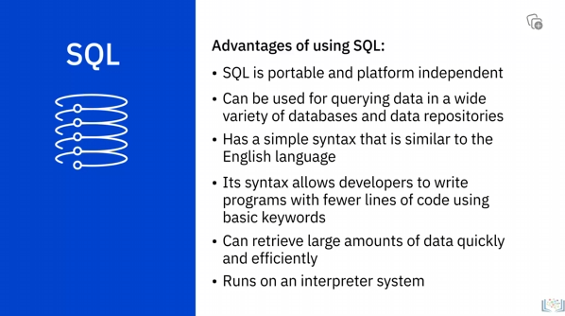

Python

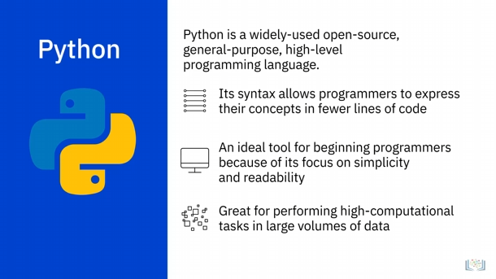

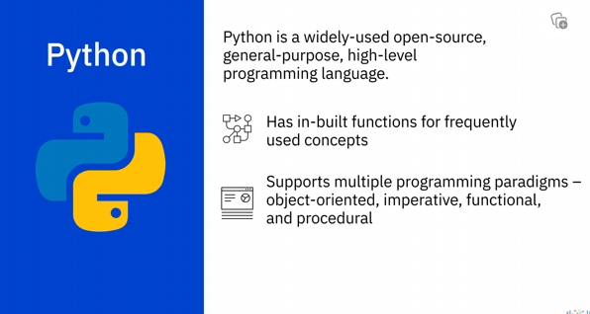

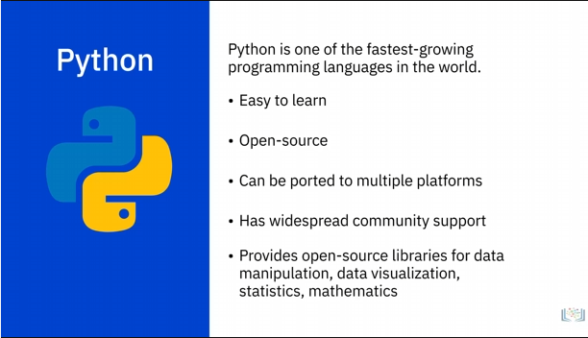

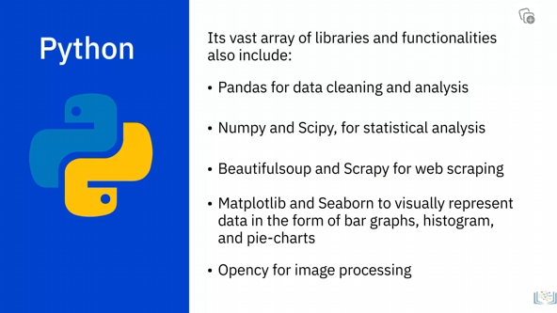

R

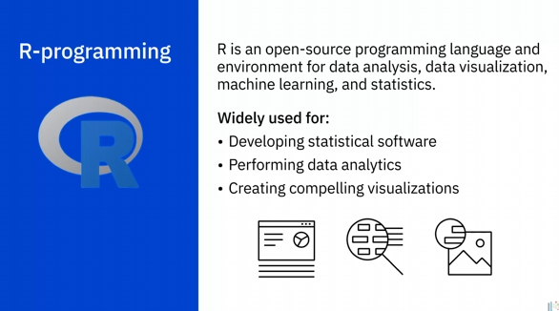

R Benefits

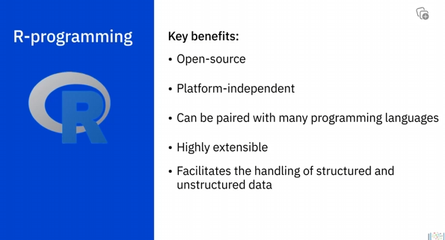

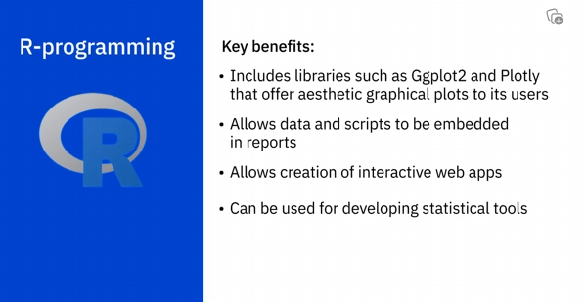

Java

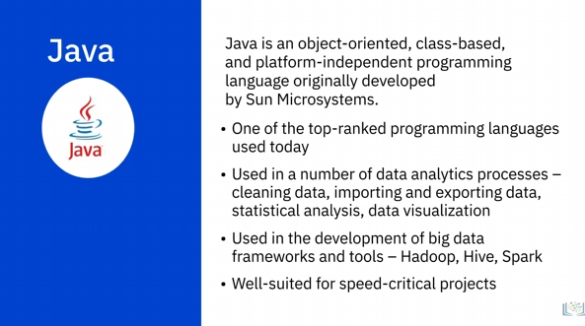

Unix/Linux Shell

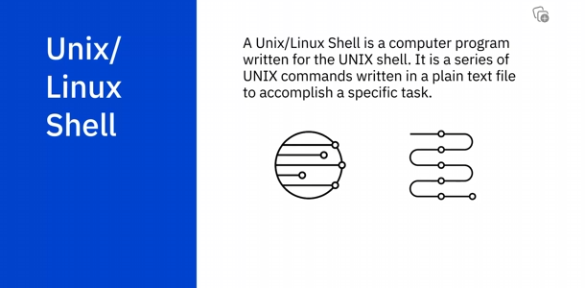

PowerShell

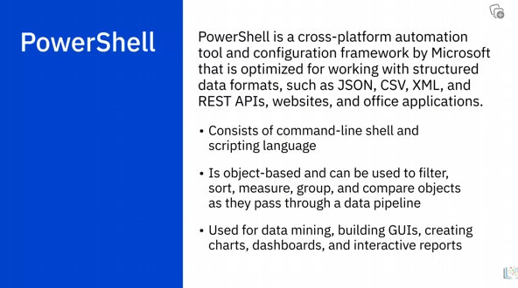

**Video: Viewpoints: Working with Varied Data Sources and Types (6:38)**

Flexibility

Cassandra and Hbase: for solving problems

Heavy write application

Variety of data sources

Pros and Cons of Different Data Formats

Apache Arvo: efficiency of storage of data

**Video: Overview of Data Repositories (4:34)**

Data Repositories Introduction

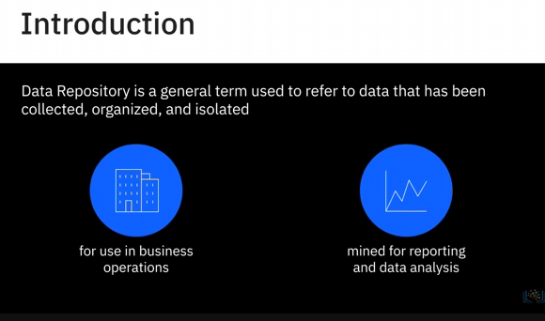

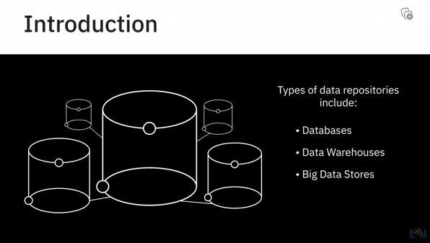

Databases

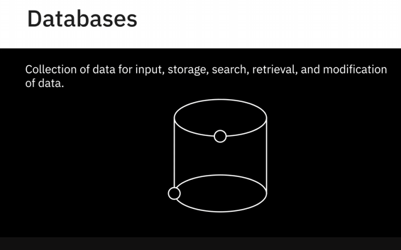

Database Management System/ DBMS

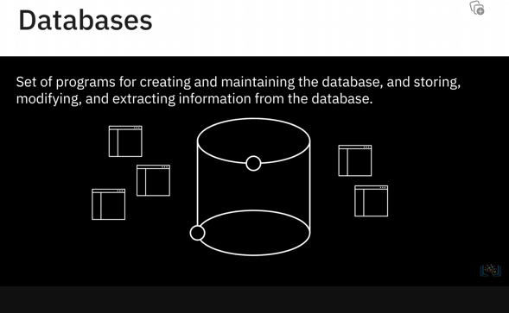

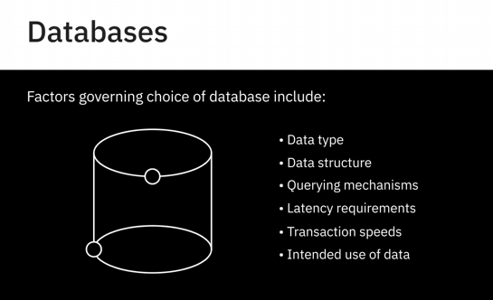

Relational Database:

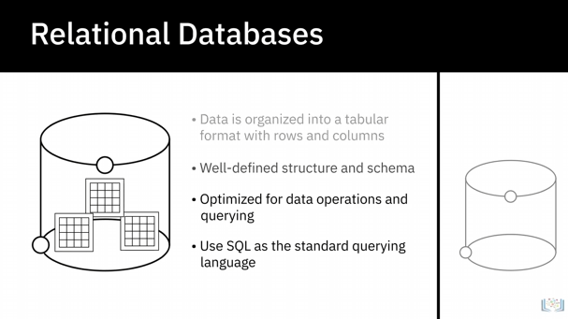

Non-Relational Database

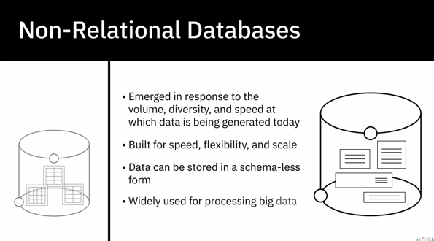

Data Warehouse

1. A data warehouse works as a central repository that merges information coming from disparate
2. sources and consolidates it through the extract, transform, and load process, also known as
3. **the ETL process, into one comprehensive database for analytics and business intelligence.**

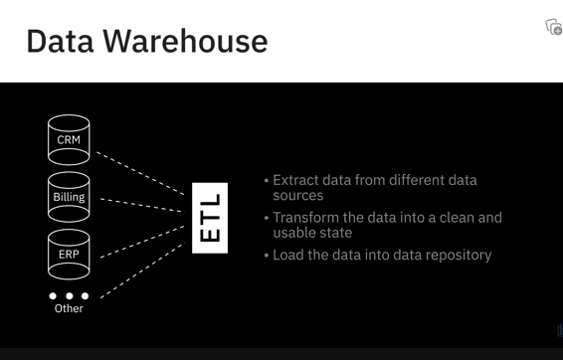

Data Marts and Data Lakes

Big Data Stores

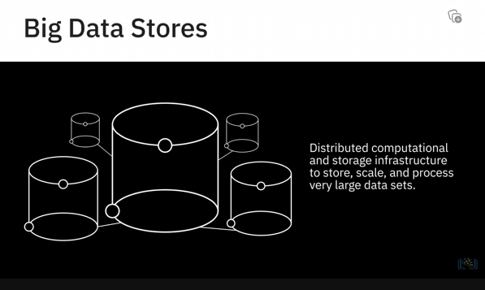

**Video: RDBMS (7:38)**

**A relational database is a collection of data organised into a table structure, where the tablkes can be lineked, or ralted, based on the data common to each**

